GAME MASTER – The Game Master will set the flow of the game. Here is your script!

BEFORE ROUND ONE - Say something like:
- We are going to do a Poverty Simulation today in the form of a game to see if you could survive a month living in poverty.
- Each of you will randomly receive an income sheet that shows you your level of education, if you’re authorized to work, and some tasks that you will have to complete each round. PASS OUT SHEETS TO STUDENTS SO THEY CAN LOOK AT THEM AS YOU TALK.
- This sheet represents the average amount of money that a person makes with the appropriate level of education. If you did not graduate high school, you will only make, on average, $250 a week on minimum wage. With a high school education, that amount increases to $400. A College degree earns $700, and a Master’s Degree earns an average of $1200 weekly – almost 10x the amount someone making minimum wage earns.
- Some of you may notice that you are not authorized to work yet, which means your first stop will be to Immigration at the front of the room to receive your VISA.
- There will be 4 rounds, and each round will be 20 minutes.
- There are three mandatory stations: transportation, housing, and food. A leader at each station will assist you and cross off your money stamps on your paper.
  - When you go to food, you will stand in the appropriate line for what food you choose to eat. Food Stamps will not get served efficiently, but they are free. If you do not eat in a round, you die.
  - Due to the Housing Equality Act, everyone gets a fair chance at housing! In theory, of course. Make one single-file line to get your housing signed off on and to pay for your rent or mortgage. You also have the option to renters or homeowners insurance.
  - You also have the opportunity to choose your transportation, including purchasing car insurance. You can also take the bus for a reduced amount of money, but it will cost you 5 extra minutes to do so. This represents the fact that it takes longer to ride the bus. If you do not secure transportation, you will not be able to earn income the next round.
- There are two optional stations – education and healthcare:
  - You can earn extra income by going to school. You will go to education and sit for 5 minutes, which earns you extra income next round.
  - Healthcare is actually not optional to us in America, but many people do not have the ability to afford healthcare and pay a penalty later. I encourage you to get immunized and health insurance if you can afford it
- Each choice you make has consequences, which may be demonstrated through LIFE CARDS. Some LIFE CARDS are good – like birthday money or Christmas cash. But some are negative – if you ate canned goods this round, has something spoiled? If you took the bus, is the route taking longer? If you didn’t get health insurance, what will happen if you get into a accident? Each round you HAVE to complete a LIFE CARD by coming to the front of the room. This is the last mandatory station.
- Some of you may need some help to complete your round, and you may ask for help from somebody else. However, if you are sitting down at a station, like Transportation or Education, you cannot ask for help or help someone. When someone helps you, they have to go with you to that station, tell the leader they are paying for you, and the leader will have to cross off their stamps and mark on your paper that you completed that round. Or, if you earned money from LIFE CARDS, you can hand that money to someone in need.
- At the end of the round, we will gather around tables in the center of the room, and our leaders will assist you by checking your sheets and giving you new ones

EACH ROUND STARTS
SAY SOMETHING LIKE: It’s a new week! Let’s see if you can survive one week in the shoes of your person.
HELP OUT THE LIFE CARDS STATION.

EACH ROUND ENDS
SAY SOMETHING LIKE: This week is over! Let’s gather up, see how you did, and your leaders will help you get your income sheets for this week!

Play FOUR ROUNDS, each one 15-20 minutes. If you notice kids are doing it too easily or dying the first round, adjust the time for the second round. You can even say things like “It’s a Holiday Weekend, so this week’s work week is shorter!” or “Time to work overtime, you have some more time!”

LIFE CARDS– Students have to complete one LIFE CARD each round. Students will choose a card, and you’ll assist students in completing their cards, cross off any stamps if applicable, and sign off completion in their box. If the LIFE CARD does not apply to them or they get free money– they got lucky! Sign off their sheet for them. Each LIFE CARD has an amount of money comparable to that real-life situation.
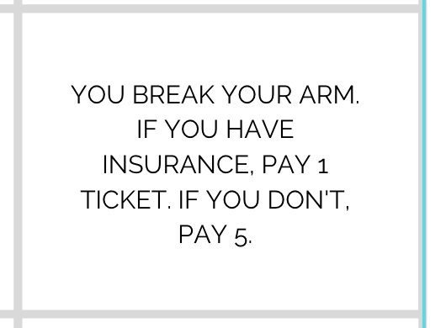
EXAMPLE:
CHANCE CARD -

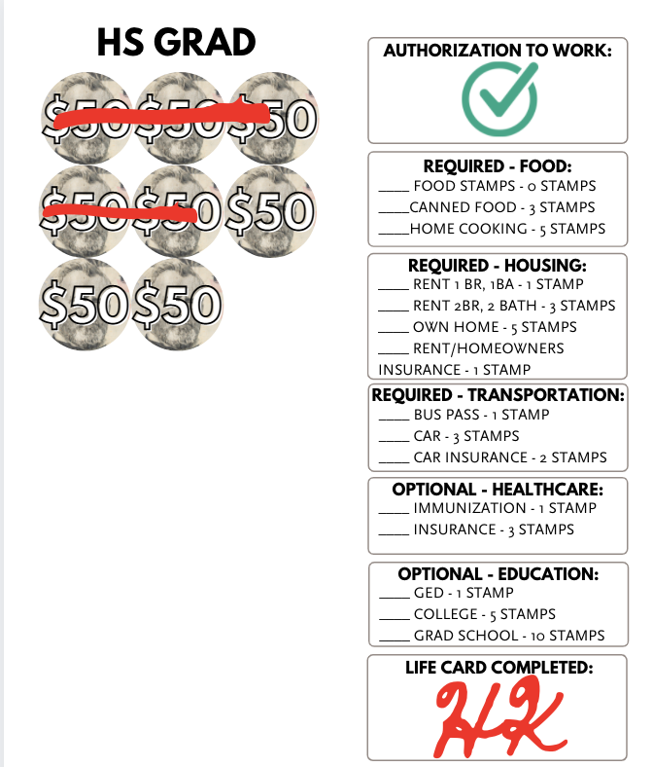

CHECK SHEET, MARK OFF IF APPLIES, AND SIGN -

IMMIGRATION – Students must receive authorization to work from Immigration. Students should make a line to receive their stamp. The Immigration Offer should make each person answer one question about the United States Government (“Immigration Questions” should be printed out on their table). If they can’t answer the question, they move to the back of the line. When it’s their turn, they may be asked a new question. When completed, the Immigration Officer initials the sheet with a Sharpie under “AUTHORIZATION TO WORK.”
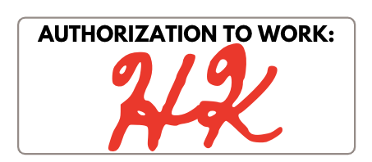

FOOD - Students Must eat each round or they “die.” Create two lines: One for Food Stamps, one for Grocery Store where people can choose either Canned Foods or Home-Cooked Meals. Favor the Grocery Store Lines by serving them first, and very visibly serve the Food Stamps Line unfairly. Use a Sharpie to mark off what they choose and the number of stamps that correlate.

EXAMPLE:
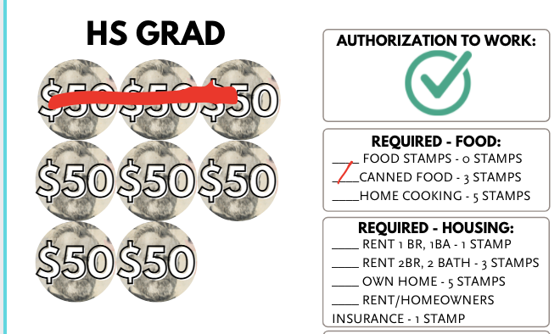

HOUSING – Students must secure housing. Have them line up in a single-file line and mark off with a Sharpie what they selected in the box on the right side of the paper, as well as mark off the appropriate number of stamps. Housing is supposed to be Equal Opportunity, but you might decide to “inspect” the papers of those who do not have college education and ask them questions like “are you sure you’re verified to work?”

EXAMPLE:

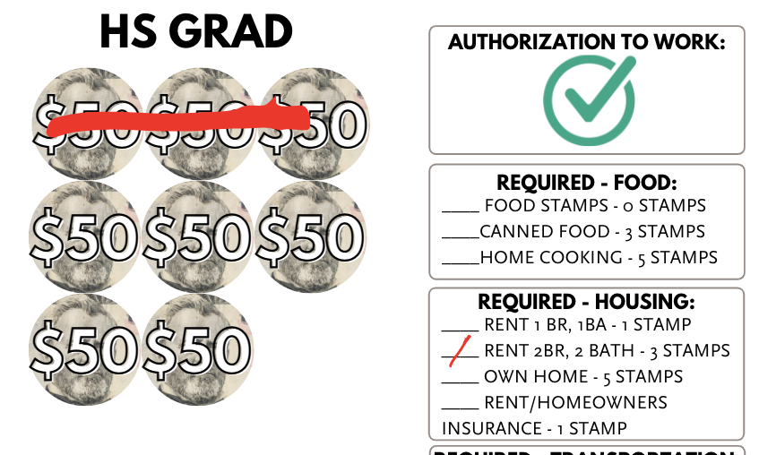

TRANSPORTATION – Students should secure Transportation each round in order to receive income next round. Have them make a single file line to make their car payment and/or purchase auto insurance. For students who wish to ride the bus, have them sit in the limited number of seats for five minutes before signing their sheets. This limited number of seats represents the limited number of seats on a city bus. When completed, mark off which transportation they chose and cross off the appropriate amount of stamps with a Sharpie.

EXAMPLE:
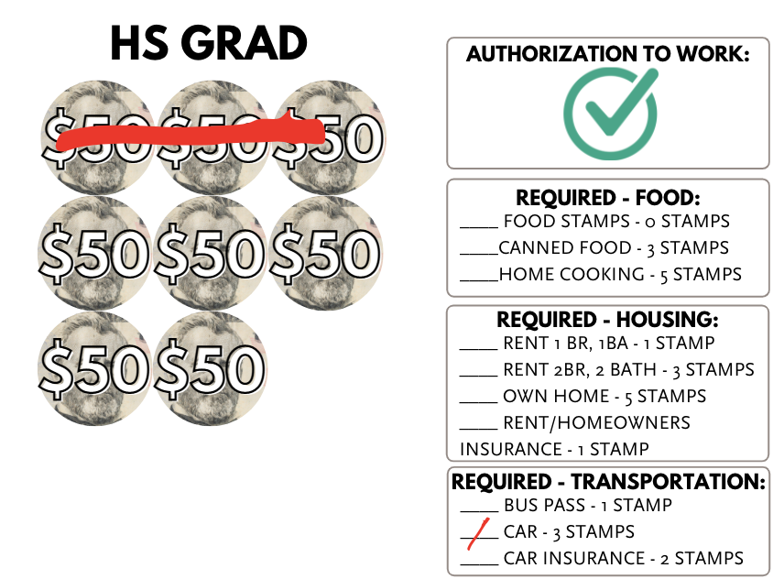

EDUCATION – Students can earn more money by completing Education. Have each student sit for 5 minutes. There are a limited number of spots, though, representing that access to education is limited. When completed, mark off their education achieved and cross off the appropriate amount of stamps with a Sharpie.

EXAMPLE:
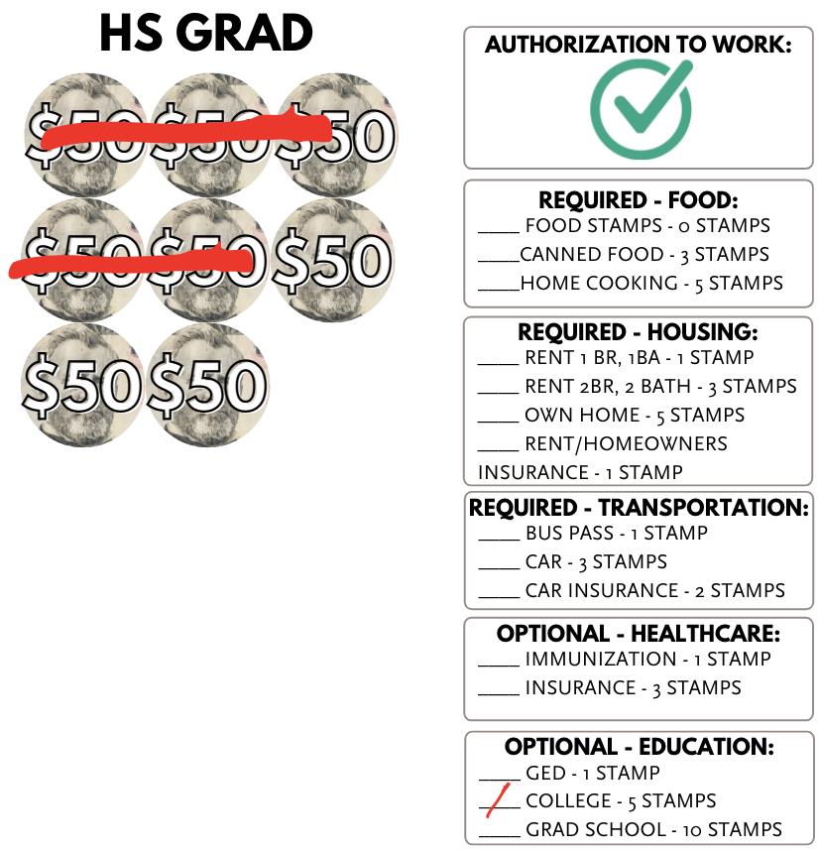

SHEETS CHECKERS – Check students’ sheets, and get them a new one.

- If they did NOT eat, then they lose the game.
- If they did not secure transportation, then they get a blank sheet with no income and have to work off of the income from the previous week, but still complete the tasks of this week.
- If they did not secure housing, they are now homeless. They will have to pay double in order to get new housing. Mark on their new sheet “homeless” so that Housing knows. If they fail to secure housing next round, they will lose the game.
- If they completed education, they will get promoted to the next tier of income.
- If they did not complete their LIFE CARD, you can choose to either deduct 5 stamps from the next round or give them grace.
- After checking their sheets, give them a new sheet corresponding with the appropriate amount of education.
  - If for some reason you run out of a higher level of form, you may say something like “Unfortunately, we just aren’t hiring any more positions at that level. You’ll have to work this lower-income position instead.”
- If they lost the game, you can also give them a second chance by starting them off with a brand new game. This way, especially with middle schoolers, they don’t get bored and into trouble.

